

2027 Image of Research Competition:
Frequently Asked Questions

I’d like to edit my image, but I don’t have photo-editing software, such as Adobe Photoshop. Where can I get it?
Adobe Photoshop is part of the Creative Cloud suite. Although Adobe Creative Cloud is no longer available to all ISU students and employees, there are a number of computer labs on campus with access, including several locations in Milner Library. There are also alternative applications with similar capabilities, including some applications that you can download and use for free (e.g., GIMP or Paint.NET for photo editing).

What size image is required?
High-resolution images are required. A high-resolution image should have at least 300 pixels per inch (PPI or pixels/inch), the general standard for printing a clear, high-quality image. Your image should also measure at least 10 inches along one dimension, preferably larger. This would mean that the largest dimension of your image should be at least 3,000 pixels (px).

How do I know if my image is of good enough quality?
When you look at your image size under file information, you will likely see the dimensions listed as horizontal by vertical (width by height). For this competition, you need a file size of at least 3,000 pixels (px) along one of the dimensions.

How do I check the image quality?

On a Windows PC, using the Photos app:
- Step 1: Open the original image. (It should be fully downloaded to your device.)
- Step 2: At the top right of the menu bar, click the three dots.
- Step 3: Select “File info.”
- Step 4: Under dimensions, this will provide the size.
If either value is greater than or equal to 3,000 pixels, your image is good to go! If both values are lower than 3,000 pixels, your image will need to be resized (see “How do I resize my image in Photoshop?”).

On a Mac, using the Photos app:
- Step 1: Open the original image.
- Step 2: Click on “Tools” in the menu bar at the top.
- Step 3: Select “Show Inspector.”
- Step 4: You will see the image size and PPI in the “General Information” box.
If the image is lower than 300 ppi, it must be resized (see “How do I resize my image in Photoshop?”).

What if my image is too small and does not meet the minimum requirement?
First, make sure you are working with the original file. Generally, photos taken with a smartphone will have the required resolution. Some platforms (e.g., social media apps) will reduce the file size (and therefore quality), so make sure to download your original photo.
For help finding an original photo taken with a smartphone, see “Where will I find my original photo?” below.
Once you have the original file, check the size following the steps above.
If your image is set to less than 300 ppi, you need to reset it to 300. To do so, you need to use a photo-editing software, like Adobe Photoshop or similar (see “How do I resize my image?” below).

Where will I find my original photo?

iPhone
If you used an iPhone, you should be able to find your original photo in the Photos application on your phone.

iCloud
If you back up to iCloud, do the following.
- Step 1: Go to iCloud Photos on your computer, and sign in.
- Step 2: Select the photo you want to download.
- Step 3: At the top right of the page (above your photos), click on the “Download” button (the button with a cloud and a down arrow).
  - Note: If you are on a smaller device (e.g., a mobile device or tablet), you will have to select the photo, tap the icon with three dots (⋮) near the top or bottom (depending on how you select the photo), and then select “Download” from the list. You can also tap the share icon (a square with an up arrow) and then select “Download.”
- Step 4: The photo will be downloaded to your Downloads folder.

Android
If you use an Android phone, you should be able to find your original photo in the Photos application on your phone.

Google Photos
If you back up to Google Photos, do the following.
- Step 1: Go to Google Photos on your computer, and sign in.
- Step 2: Select the photo you want to download.
- Step 3: Click on the 3 dots (⋮) icon in the top-right corner of the page.
Note: If the photo is already on your device, this option may not appear, and you should be able to search for the photo on your device.
- Step 4: Select “Download” from the list.
- Step 5: The photo will be downloaded to your Downloads folder.

How do I resize my image in Photoshop?
- Step 1: Open your original image in Adobe Photoshop (see Figure 1 below).
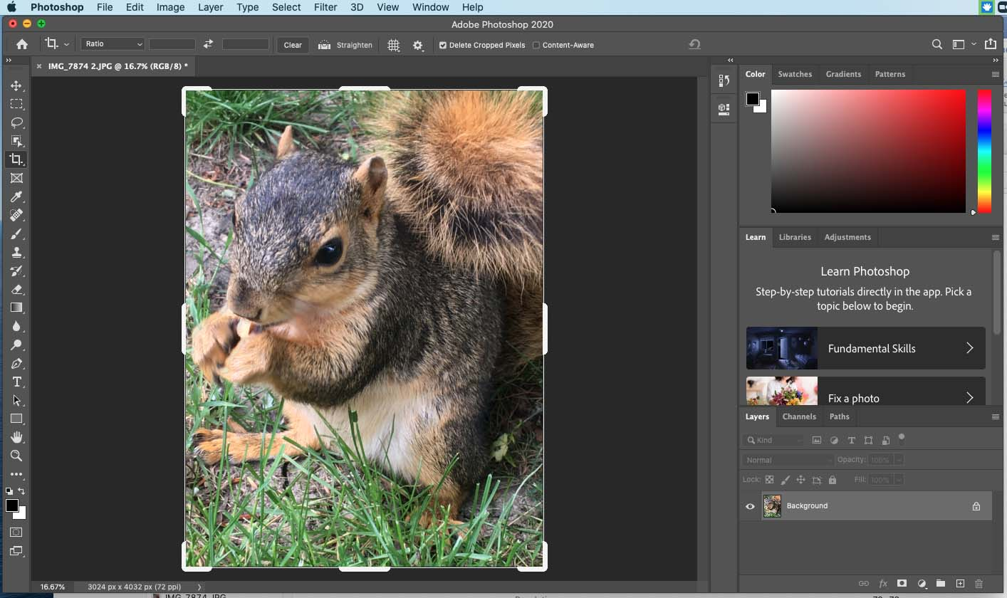
Figure 1. Original photo opened in Photoshop.
- Step 2: Click the “Image” tab. Select “Image Size.” Then change the resolution to 300 pixels/inch (see Figure 2 below).
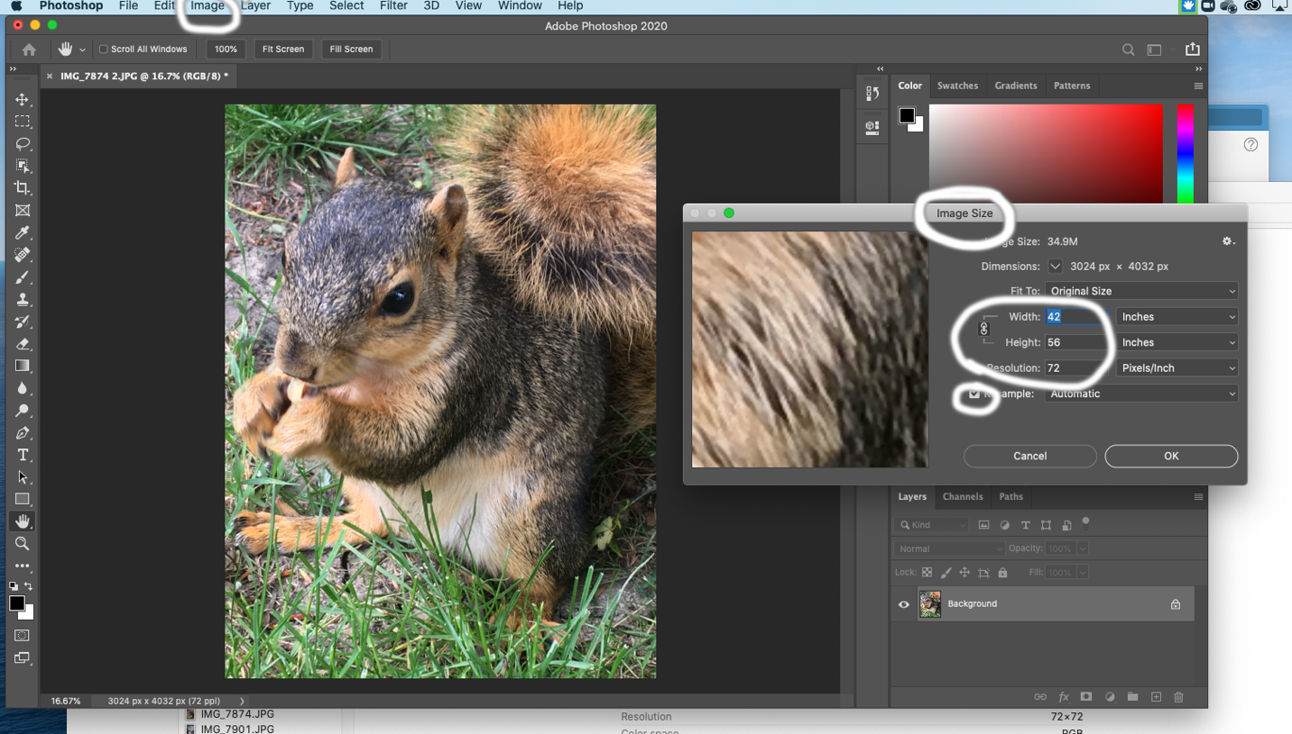
Figure 2. Showing the "Image Size" of the photo with a resolution of 72 pixels/inch. (It is 52 inches wide by 56 inches high.)
  - For most circumstances, deselect “Resample” and change the resolution to 300 pixels/inch.
  - Then check the height or width of the image, and make sure that it is at least 10 inches. If needed, set the smallest side to 10 inches. If the image is not blurry or pixelated, you can just save the image! (See Figure 3 below.)
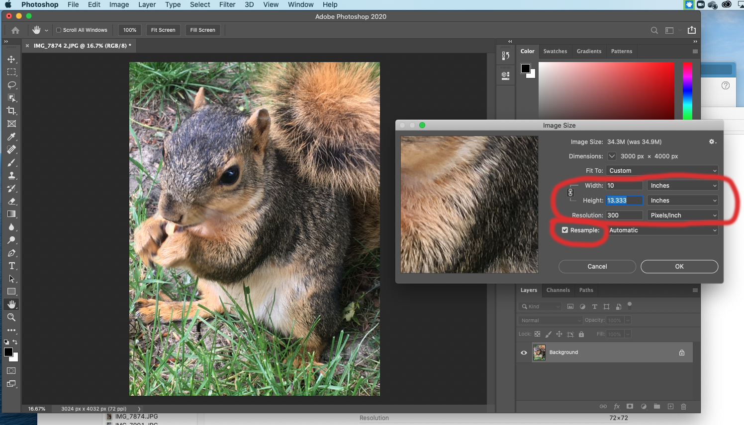
Figure 3. Showing the "Image Size" of the photo with the resolution changed to 300 pixels/inch. It is now 10 inches wide by 13.333 inches high.
- Step 3: If changing the size to 300 ppi has shrunk your image below 10 inches on one side, you may need to resample the image. Select “Resample,” change the longest side to 10 inches, and choose a method for resampling in the drop-down menu. Start out with the “Nearest Neighbor” method and see how it looks. If that looks bad, try the “Bicubic Smoother” or “Bicubic Sharper” method.
  - Note: Resampling the image changes the amount of data in the image. This gets a little complicated because it’s actually adding or deleting data from the image. This can sometimes lead to some wacky-looking stuff.
  - If you are trying to make the image considerably larger than the original, this process can get a little weird, and it’s best to go back to the source photo and see if there’s any way to get it in a larger file size from the get-go.
If you are using another photo-editing program, the menus may differ slightly, but the procedure should be the same. If you need help with Photoshop or other applications, there are many online tutorials.

What if I have questions about my submission or the application?
If you have questions, contact Ashley Waring-Sparks, Interim Director of the Office of Student Research, alwarin@ilstu.edu.

